

**This Revision: 06/17/2016**

**Last Revised: 03/31/2015**

**EO-1 Mission Operations Phase F Summary**

**2016**

Table of Contents

1.0 Spacecraft Mission Operations**4**

1.1 Spacecraft Health Assessment4

1.2 Assumptions 4-5

2.0 EO-1 Phase F Science Plan **5**

2.1 Baseline Science Data Products 5-6

2.2 High Priority Science Efforts 6

2.2.1 Sustainable Land Imaging Analyses6

2.2.2 Lunar Calibration Analyses6

2.2.3 HyspIRI Mission Support6-7

2.2.4 Analyses of Earth Data7

2.2.4.1 SNR7

2.2.4.2 Carbon Cycle7-8

2.2.4.3 Algorithms8

2.2.4.4 Land Use/Land Cover8

2.2.5 Visualization to Aid User Community8

2.3 Work to be Transitioned 8

2.3.1 Disaster Management Assistance8

2.3.2 Sensor Web Connections8-9

3.0 Spacecraft Decommissioning **9**

3.1 Overview of Decommissioning Activities9-12

3.1.1 Intent to Terminate Notification & Finalization of EOMP Report12

3.1.2 Decommissioning Review12-13

3,1,3 KDP-F Review13

3.1.4 Perform Fuel Depletion 13

3.2 Spacecraft Passivation 13

3.2.1 Disposal Readiness Review13-14

3.2.2 Passivation 14

3.2.3 Write Spacecraft Final Report 14

3.2.4 Spacecraft Reentry Analysis 14-15

4.0 EO-1 Flight Operations Team Closeout Activities **15**

5.0 Ground System Closeout Activities **15-16**

5.1 EO-1 Documentation Archive 16

5.2 Facilities/Equipment Disposal 16

6.0 Budget Analysis **17-18**

7.0 Conclusions/Summary **18**

Appendix A: Figure 3 EO-1 Passivation Table **19-20**

Appendix A: Figure 4 Ground System Activity Schedule **21**

**1.0 Spacecraft Mission Operations**

This Phase F report contains management planning information for the decommissioning of the EO-1 mission. Decommissioning includes spacecraft passivation, operations shutdown, and final mission documentation. The NASA Headquarters Earth Science Division on advice from the 2015 Senior Review panel decided to terminate the EO-1 mission starting October 2016 with spacecraft passivation occurring November 2016 through February 2017 and full operations shut down to occur by March 2017. The EO-1 spacecraft was designed from inception to be operated by a stand-alone Flight Operations Team (FOT) and Ground System located in a Mission Operations Center (MOC) at the Goddard Space Flight Center (GSFC) in Building 14. Many years of cost savings have been achieved by implementing autonomous operations both on board and on the ground. EO-1 ceased flying in formation with Landsat-7 in October 2007 and therefore does not have to break formation during decommissioning. EO-1 is managed under GSFC Earth Science Mission Operations (ESMO) Branch, Code 428.

**1.1 Spacecraft Health Assessment**

The EO-1 mission is currently healthy flying in a nearly sun-synchronous orbit with descending node occurring during the daylight. However, the hydrazine fuel was mostly depleted in February 2011. Small maneuvers have been successful for debris avoidance (e.g., May 2014), but long duration burns (e.g. orbit maintenance and inclination maneuvers) are not being performed due to insufficient fuel. Therefore the orbit is slowly degrading and the Mean Local Time which was maintained at 10:00AM prior to February 2011, is drifting earlier and will reach 8:00AM at the end of September 2016. Orbital parameters at an Epoch of 9 May 2016 00:00:00z expressed as Classical Orbital Elements in the J2000 coordinate frame were:

* Semi-major axis: 7060.495 Km
* Eccentricity: 0.000498
* Inclination: 97.89 Degrees
* RAAN: 171.133 Degrees
* Argument of Perigee: 13.570 Degrees
* True Anomaly: 321.222 Dg

The Apogee and Perigee altitudes at that time were as follows:

* Apogee: 685.876 Km
* Perigee: 678.839 Km

The EO-1 spacecraft is capable of supporting full science operations with all instruments and typically takes 20-25 images per day with both the Advanced Land Imager (ALI) and the Hyperion hyperspectral imager. Even though the LEISA Atmospheric Corrector is functioning, it is not typically used for imaging to save space on the recorder for ALI and Hyperion scenes. EO-1 is expected to be functional through the entire decommissioning phase. There are no other subsystems-specific issues expected to limit the lifetime of any major spacecraft subsystem or component on-board EO-1 through the duration of the mission shut down. Therefore, using the scenario of October 1st of 2016 as a starting point for decommissioning, a timeline is shown in order to accomplish all steps for spacecraft passivation (see Figure 1).

**1.2 Assumptions**

1. Spacecraft has full capabilities needed to perform passivation. The list of components that need to be functioning to accomplish passivation include solar array, battery (at least 18 cells out of 22), command and data handling (C&DH) subsystem, attitude control electronics, star tracker, sun sensors (at least 3 out of 4), and S-band communications subsystem. There are no redundant components except for the sun sensors that are mounted on the solar array.
2. EO-1 will purge propellant in the retrograde direction at apogee to lower perigee and shorten total re-entry time, if possible. If any EOS Constellation members have to leave the formation prior to the tank purge being completed and if breaking the formation increases the possibility of EO-1 being in the way, a decision can be made to use any remaining fuel to try and get out of the way instead of reduce reentry time. This decision can be made at any time between now and passivation and not endanger the passivation activity in any way.
3. All Spacecraft passivation products have been finalized before Decommissioning Review. Passivation products are under development as of this writing and will undergo several peer reviews during the End Of Mission Plan (EOMP) update leading up to Decommissioning Review.
4. All activity execution is nominal.
5. The current operations work force is in place at the Key Decision Point (KDP)-F milestone.
6. **EO-1 Phase F Science Plan**

The following sections describe the disposition of the EO-1 data products and documentation as well as the science activities to be completed during the final Phase F for the EO-1 mission.

* 1. **Baseline Science Data Products**

The highest priority of the EO-1 mission during Phase F for science support will be to ensure preservation of archive data products and documentation. These have been developed with support from the U.S. Geological Survey (USGS) at the Earth Resources Observations for Science (EROS) center in Sioux Falls South Dakota. The entire mission data set and documentation is resident at the USGS EROS under the Earth Explorer system (<http://earthexplorer.usgs.gov/>) consisting of:

* Raw binary data from X-band downlinks at ground stations (I and Q channel interleaved containing 14 bit detector data number units)
* Level 0 uncorrected radiances in watts per square meter units including housekeeping telemetry metadata in HDF5 format
* Level 1R corrected radiances in watts per square meter also in HDF 5 format
* Level 1G systematically geolocated individual band files in GEOTIFF format (each containing watts per square meter units per band)
* Level 1T ortho-rectified GEOTIFF band files (watts per square meter per band) for scenes less than 30% cloudy to allow co-registration with the Landsat Global Land Survey dataset

The EO-1 data products and documentation will exist at EROS for future generations as long as the Landsat data and documentation are maintained by USGS. Experimental products and near-real-time data are processed and stored on a cloud computing platform operated by the Open Cloud Consortium (OCC) under a 5 year NSF grant that will continue through October 2017. Currently, copies of all L0, L1R and L1G data for ALI and Hyperion acquired since 2014 are being stored on the Matsu cloud (~400 terabytes of data) available at <https://matsu.opensciencedatacloud.org/eo1/>. These data duplicate the USGS/EROS archive since 2014 and are used by rapid response users and by the EO-1 team to extend the data product offering by adding experimental data products daily including atmospheric corrections for Level 2 reflectance and feature identification/index classification algorithm results. These experimental products will be included in the final archive data and documentation provided by the EO-1 team through GSFC Flight Directorate and Center archivist to the National Archives. The duplicate EROS data will be deleted from the Matsu cloud when the end of the NSF grant is reached.

The entire set of Hyperion and ALI Lunar calibration data are resident at EROS in level 0 format, but the Hyperion Lunar calibration data have been processed to Level 1R for the entire mission and are resident on the Matsu cloud platform. The Hyperion Lunar calibration L1R data set and documentation on the algorithms and metadata (including default processing parameters) will be packaged for long term storage in the GSFC Flight Projects Sharepoint database, the GSFC Center-level archives, or the National Archives as determined by the close-out team in conjunction with the ESMO documentation technician, the Flights Projects management, the GSFC Archivist, and the National Archives Point of Contact.

Another set of EO-1 data products and experimental results are stored on the password protected Autonomous Sciencecraft Experiment (ASE) website at the Jet Propulsion Laboratory (<http://www-aig.jpl.nasa.gov/public/planning/eo1/operations/listallsciencegoals.cgi).> The disposition of these data after the close-out of the mission are to be determined by the JPL curators. The ASE flight software and ground scheduler currently running on EO-1 is still under a license from Caltech for the specific purpose of supporting EO-1 operations. All other ground system information and software (except for the scheduling code and the flight software) will become part of the archive for the mission. The ASE flight software and ground scheduler are available for license via Caltech, specifically fee free for government use and can be requested from them. Caltech will not provide authorization for NASA to include the ASE source code in our archives.

* 1. **High Priority Science Efforts**

In addition to data product archiving and documentation efforts to be conducted during Phase F, there are several high priority science efforts that utilize data being collected during the last year of the mission, especially the new data collected after the 2015 Senior Review. These ongoing science efforts will continue until near the end of the mission close-out, then will be wrapped up and published as science results. The results will become part of the mission archive to he delivered to the National Archives.

* + 1. **Sustainable Land Imaging Analyses.** The Hyperion instrument is currently the only operating spectrometer in space and plays a unique role in inter-comparison across optical imaging satellites and convolution/simulation of band combinations in support of the Land Surface Imaging Constellation, a new constellation under the Committee on Earth Observation Satellites (CEOS). The EO-1 mission science team will conduct analyses to demonstrate this utility on existing and new satellites during the remaining life of the mission and will document those in publications and archive deliveries.
    2. **Lunar Calibration Analyses**. EO-1 now has a unique collection of more than 160 lunar scenes, of high interest to the CEOS calibration community. Most of these were imaged during the positive 7 degree phase of the full moon, but many (especially for 2015 and 2016) have been taken at other phase angles to match the calibration techniques being employed on numerous other satellite missions. Therefore, the EO-1 mission in partnership with NOAA and USGS is performing a comprehensive analysis of this existing 15 year collection of monthly spectral exo-atmospheric lunar observations, collected for a range of lunar phase angles surrounding the fully illuminated moon. EO-1 revised the observation strategy in early 2013, and are currently characterizing the radiometric stability of specific lunar surface features, such as mares, in the presence of lunar nutation and libration. This effort is necessary to develop satellite-based lunar irradiance models as alternatives to the RObotic Lunar Observatory (ROLO) and similar methods that will enable radiometric inter-calibration of spaceborne imaging sensors (including Landsat-8) and future high quality imaging spectrometers such as HyspIRI. The results will be completed in a report by the mission close out and become part of the mission archive along with the Level 1R Hyperion lunar calibration dataset.
    3. **HyspIRI Mission Support**. EO-1 continues to support this future mission, and other missions, by development of an Intelligent Payload Module (IPM) for low latency products. The Hyperion data, in conjunction with AVIRIS aircraft spectrometer data collected in coordination with the HyspIRI Airborne Campaign during 2013-16 are being used to build spectral libraries for pre-launch simulations and to generate prototype products for HyspIRI and other future missions (e.g., EnMAP, EU/DLR for launch in 2014). Support for the science team for these activities is provided under a separate budget for the HyspIRI mission and many of the activities may continue after the EO-1 mission close out. However, sometime after December 2016 it is anticipated that no more EO-1 images will be gathered in support of the HyspIRI flight campaign. Between passivation and decommissioning, time is reserved for special imaging and engineering activities up until passivation.
    4. **Analyses of Earth Data**
       1. **SNR**. The Mission Science Office will evaluate and quantify the degradation of SNR and data quality of both the Hyperion and ALI sensor data collected during the precession mission phase at an earlier local overpass time (<10AM). A review of these results was conducted at NASA Headquarters (HQ) during February 2016 and the review panel found that the quality of EO-1 data was sufficient to continue operations through the nominal decommissioning timeline outlined in this report. The final results of these evaluations are being published and will become part of the mission archive.
       2. **Carbon Cycle**. Evaluation of the Hyperion globally distributed spectrometer time series at calibration/validation stations will be performed, to develop retrieval methods for carbon cycle science as a baseline for future spectrometer (e.g., HyspIRI) studies for climate change. These analyses will be published and become part of the EO-1 mission archive, but some of the activities will continue after the mission close out under funding from the HyspIRI mission.
       3. **Algorithms**. The team will support development of robust algorithms for Hyperion data to be applied to future hyperspectral missions, such as EnMap, PACE, and HyspIRI, to track vegetation function via time series analyses and for scaling carbon dioxide dynamics across multiple sites, from local and regional levels. We will be analyzing the recently updated global carbon flux data from the LaThuile Fluxnet synthesis project, matched to existing Hyperion imagery, at 33 globally distributed flux tower sites that represent different vegetation types. The results of these analyses will be published and become part of the EO-1 mission archive
       4. **Land Use/Land Cover (LU/LC)**. Evaluations of new (2012-present) Southern Hemisphere acquisitions, paired with those made in 2001-2002 in the original field validation campaigns, will be performed for land cover and land use changes that occurred in the past decade. These results will also be published and become part of the mission archive.
    5. **Visualization to Aid User Community**. Procedures are under development using existing EO-1 data, applicable to many satellite missions, to support streamlined steps for the user community, by providing tools for quickly finding the data of interest and facilitating data delivery. To assist users, we intend to increase the archive size on the Matsu cloud to one petabyte or more, with pre-calculated tiled data products which are integrated into a Hadoop GIS database, allowing rapid visual navigation of the tiled data products through the use of a Web Map Server and various time, spatial, and spectral filters. This also involves transforming the user interface to enable multiprocessing through the Eucalyptus operating system for cloud computing, thus improving the user experience. The software for this activity will become part of the final hand-off of the Matsu effort to the NSF for archival there.
  1. **Work to be Transitioned**

For the following activities, personnel will be transitioning functions to other projects during or after Phase F assuming funding is available to continue supporting these activities without EO-1 direct funding. The EO-1 Flight Operations Team (FOT) members will no longer support EO-1 upon completion of Phase F.

* + 1. **Disaster Management Assistance**. Although nominal image operations will be curtailed sometime starting in October 2016, the EO-1 team is involved in disaster training, assisting the operational staff at regional and national disaster management and civil protection offices (e.g., US Forest Service, USAID, World Bank, UN, Red Cross/Red Crescent Societies, SERVIR). The EO-1 team leads the CEOS Disaster Risk Management Flood Pilot tasks in southern Africa, Southeast Asia, and in the Caribbean/Central America and will continue in that role after decommissioning of EO-1 under funding through the NASA Disasters Program, SERVIR, and other sources.
    2. **Sensor Web Connections**. EO-1 is the world leader in Sensor Webs, to task satellites for rapid map production for disaster support with CEOS agency partners. The team collaborates with other modeling teams to improve predictions by integrating ground truth data and satellite observations back into future model iterations, especially for existing projects in southern Africa and in the Caribbean/Central America. Team members presented a talk at the Ground System Architecture Workshop plenary session in March 2016 and many of the participants from other agencies and commercial providers have sought collaborative input to their projects based on the results presented at GSAW. In addition, targets that are setup in the Sensor Web tasking system for EO-1 are being routinely harvested by other external systems to automatically retrieve and process data from other satellites via the Atom feeds provided by the EO-1 system. These other external systems include an automated Landsat flood processing system that is triggered to retrieve relevant Landsat images by new EO-1 entries for flood targets that are setup by users of the Sensor Web tasking system by thematic area. The Landsat system automatically processes the retrieved images into flood extent maps. On-going support for the Sensor Web services will be sought during the mission close-out. The software and system configuration information will become part of the EO-1 mission archive. If no support to maintain the system is found, it will be shut down by July 2017.

1. **Spacecraft Decommissioning**

The timeline table and schedule chart below highlight the decommissioning activities and schedule. They contain the activity titles, the beginning dates, the task durations, and any comments needed to fully describe each action.

* 1. **Overview of Decommissioning Activities**

|  |  |  |  |
| --- | --- | --- | --- |
| Mission Operations, Science and Decommissioning Timeline | Beginning Date of Activity | Duration | Comments |
| Science Activities |  |  | Selected key activities |
| Generate Level 2 Reflectance | 10/1/16 | 1 year | Provided on demand, improvements for water and diverse terrain |
| Prototype Land Cover Products | For HyspIRI, NASA Terrestrial Ecology, Carbon Cycle and Climate Change, Bio-physical variables (Veg. fraction, pigments, Leaf Area Index, moisture, Albedo) |
| Support NASA SLI and NEW Satellite Missions | Data fusion and prototype products (ALI, Hyperion, Landsat, SENTINEL 2 Multi-Spectral Imager) |
| Spectral time series for VEGETATION targets | FLUX sites, instrumented sites (e.g. SpecNet, Land Equipped Sites), Long Term Ecological Research |
| Spectral time series for CAL/VAL targets | CEOS Pseudo-Invariant Calibration Sites, VIS/NIR sensor intercomparison |
| Disaster Response and Mitigation | 12/31/16 | 2-3 months | Relief efforts- floods, hurricanes, fires, volcanoes-Section 2.3.1 |
|  |  |  |  |
| Decommissioning Timeline |  |  | From deliver of Intent to Terminate notice to Passivation completion Section 3.1 10/1/2016 – 3//31/2017 |
| Phase F Plan Update and Review by ESMO | 6/1/16 | 1 day | Contained in this update |
| Update End of Mission Plan | 7/1/16 | 60 days | EOMP will require 60 days to be completed including internal review and sign-off at GSFC |
| Finalize detailed timeline of Decommissioning Activities | 8/15/16 | 15 days | This artifact of the EOMP update will form the starting point for the Decommissioning Plan development. Build flight content are identified and worked prior to Final Build Content Review |
| Receive direction from NASA HQ to begin termination process flow | 8/31/16 | 1 day | Initial trigger to begin proposed steps below. This is the expected delivery date of Satellite Asset Protection Program report. Invitation to GSFC Code 500 AETD management will be sent this date to solicit other input of end of mission experiments |
| Deliver End of Mission Plan to NASA HQ | 9/1/16 | 30 days | 30 days are allowed for final EOMP review and approval by NASA HQ |
| Ground System Freeze | 9/1/16 (See section 5) | 1 day | Only changes required for Passivation will be accepted for implementation |
| Develop Decommissioning Plan | 9/1/16 | 60 days | Final Decommissioning Plan will require 60 days to be completed including chaining together all passivation activities, analysis of timing considerations, execution durations, communications constraints, and FOT work hours |
| Passivation Simulations and Rehearsals | 10/1/16 | 75 days | Flight Operations Team and Flight Systems Engineering preparatory activities |
| Notification of Intent to Terminate is sent to Administrator with updated EOMP | 10/1/16 | 1 day | Per NASA Policy Directive NPD8010.3B Notification of Intent to Decommission or Terminate Operating Space Systems and terminate Missions must precede the Decommissioning Review by 90 days-Para. 3.1.1 |
| Prepare for Decommissioning Review | 10/1/16 | 90 days | Allow 90 Days from Intent to Terminate Notification to Decommissioning Review |
| Final flight build content review | 10/15/16 | 1 Day | Review content of flight passivation build procedures and patches |
| Final flight build ORR and delivery | 12/1/16 | 1 Day | Approve flight passivation build procedures/patches and prepare uplink commands |
| Decommissioning Review | 1/5/17 | 1 day | This is GSFC review prior to Key Decision Point (KDP-F)-Para. 3.1.2 |
| Perform Pulse Plasma Thruster Test and other engineering tests | 1/12/17 | 17 days | Could consider performing some engineering tests prior to HQ authorization to decommission at KDP-F Review-Para. 3.1.3 |
| Start Mission Final Report | 1/15/17 | 105 days | Allow time to document all mission accomplishments |
| NASA HQ Decision to Terminate Mission – KDP-F | 1/20/17 | 1 day | Mission presentation to NASA HQ Earth Sciences Division for KDP-F |
| Disposal Readiness Review | 2/1/17 | 1 day | After Decommissioning Review but before the execution of passivation activities to approve execution of passivation activities- Para. 3.2.1 |
| Execute passivation activities  Instrument Turn-off  Disposal of fuel  S/C Passivation  Verification of RF Silence | 2/3/17 | 25 days | See EOMP for final spacecraft configuration details-Para.3.2.2 |
| Archive flight and ground system data and software | 3/15/17 | 15 days | See Phase F Report (this document) Section 5.1 for archive plan |
| Decommission Ground System Hardware (Excess) | 3/31/17 | 60 days | Operations documentation and data archive delivered through project CM, Flight Projects Sharepoint, Center archivist, and National Archive packaging reviews |
| Archive System Data and Documentation |
| Facilities/Equipment Disposal |
| Contract/Agreement Modification and/or Closeout | 4/1/17 | 30 days | Contracting Officer and COTR involvement |
| Mission Accomplishments Review at NASA HQ | 4/1/17 | 1 day | Preview of final report contents that began development immediately following the Decommissioning Review |
| EO-1 Operations and Science Documentation Closeout and Archive | 4/1/17 | 180 days | Upload electronic version to center-level repository. Inventory, box, label and ship hard copy and DVD’s to National Archive |
| EO-1 Mission Final Report | 4/30/17 | 75 days | 71 days from passivation completion-Para. 3.2.3 |

Figure 1, EO-1 Phase-F Timeline shown as a table and as a schedule chart

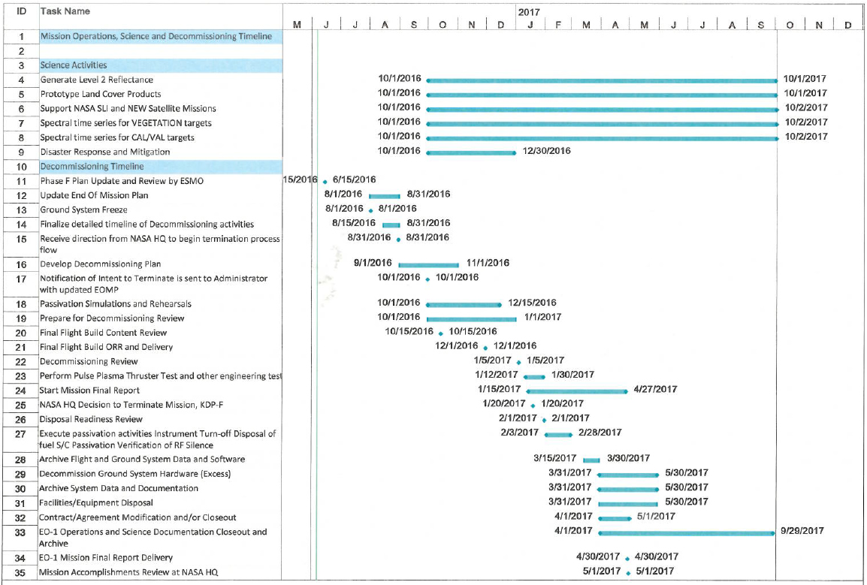

The entries in Figure 1 (including the table and the corresponding schedule chart) assume a 10/1/2016 official start to the decommissioning phase of the EO-1 mission.

* + 1. **Intent to Terminate Notification & Finalization of EOMP Report**

In compliance with NPD 8010.3B, the EO-1 mission will send the NASA Headquarters (HQ) Science Mission Directorate (SMD) a Notice of Intent to Terminate Mission letter and an updated version of the EO-1 End-of-Mission Plan (EOMP). The SMD will notify the NASA Administrator of the intent to terminate the EO-1 mission. The EO-1 mission will inform all external interfaces including the 705 km Constellation members, the Conjunction Assessment and Risk Analysis (CARA) Team, and the EO-1 users such as the research community and science users in addition to the Sensor Web and disaster management communities. All other notification is assumed to be conducted by the NASA HQ Executive Office.

* + 1. **Decommissioning Review (previous to KDP-F at HQ)**

After the Notification of Intent to Terminate is sent to the Administrator with updated EOMP and after waiting the required 90 days, the mission will conduct the Decommissioning Review. The Decommissioning Review will be conducted by ESMO, and will include the spacecraft passivation plan as well as the facility close-out activities. The EOMP will be approved at this review. In addition, the detailed steps to accomplish the passivation will be reviewed as documented in the Decommissioning Plan.

* + 1. **KDP-F Review (at HQ)**

Following this GSFC review, the decommissioning plan will be presented at a panel review conducted by NASA HQ. After that HQ review, the Director of Earth Science will have five (5) working days to reply back to ESMO, the EO-1 Project Scientist (E. M. Middleton, Code 618), Mission Manager (D. Mandl, Code 582), and the rest of the mission support groups to inform them of their final decision. Up until this point, the mission can still be asked to continue. However, once the decision is made to proceed, the passivation sequence will begin with only weeks remaining before complete mission termination.

* + 1. **Perform Fuel Depletion and Other Engineering Tests**

In order to purge all remaining fuel from the tanks, fuel depletion activities will be performed. EO-1 was granted a deorbit waiver on October 15th 2007 (Waiver #OD-07-05), and was authorized to utilize all remaining fuel for maintaining the Mean Local Time (MLT) instead of lowering the orbit to the prelaunch reentry elevation. All viable fuel was used up on February 15th 2011 during an MLT maneuver. It is estimated that less than 0.3kg of hydrazine still remains in the fuel tank, but that amount is sufficient for performing small debris avoidance maneuvers. The fuel purge execution will be performed in the retrograde direction at apogee so that any thrust obtained will contribute to reduction in the time to reentry by further reducing perigee. The fuel purge sequence will be conducted over a period of 4-5 days to allow for analysis of burn performance after each after revised definitive orbit calculations have been performed. Before and after the fuel depletion, engineering tests will be conducted as outlined in the Space Asset Protection Program plan for utilization of EO-1 during decommissioning. Tests include final firing of the pulse plasma thrusters to prove no Hyperion contamination from PPT ignition of teflon fuel source and rebooting of the Command and Data Handling computer to ensure clearing of the Medium Speed Serial port hang that caused degradation in playback of recorded telemetry on-board.

* 1. **Spacecraft Passivation**

Following a successful fuel depletion, the focus will shift towards preparing for the final passivation of the mission. The flight operations team will conduct their final passivation rehearsals and simulations and prepare for the disposal readiness review.

* + 1. **Disposal Readiness Review**

ESMO will conduct this review in the week following the completion of the fuel purge and recovery. Support from the Applied Engineering and Technology Directorate (AETD), flight software maintenance and spacecraft manufacturer is assumed until passivation has been completed. The goal of this review will be to determine that the team has completed all outstanding actions, has formally addressed all Requests for Action from the Decommissioning Review, and is ready to terminate the mission. This review will ensure that the spacecraft is left in a power negative posture and that is will not be able to revive itself after the control center has been dismantled. The review also ensures that the FOT can accomplish all the passivation steps and do so at the appropriate level of risk.

* + 1. **Passivation** (See Figure 3 - EO-1 Passivation Configuration)

After proper approval has been given at the Disposal Readiness Review, and in accordance with the configuration-managed Final End-of-Mission Plan (EOMP) and the Decommissioning Plan, the team will then passivate the vehicle. The passivation activities should take three weeks to complete, including a two week time period allotted to verify that no Radio Frequency (RF) signal can be acquired from EO-1 and therefore verify that the passivation was successful. This will require that at least one fully capable string of the ground system is in place to support this activity.

* + 1. **Write Spacecraft Final Report**

While the ground system and facilities are being closed out and the data archives are being gathered (maximum of 90 days from spacecraft passivation), the Final EO-1 Spacecraft Operations Report will be written. This report will detail the operations and performance of the Spacecraft, Instrument, and Ground Systems and describe any lessons learned for future mission teams to consider.

* + 1. **Spacecraft Reentry Analysis**

Based on a DAS assessment performed by JSC, a Survivability Analysis Report for EO-1 has not been prepared. According to the OSMA at JSC, the only component that poses any risk of reaching the earth is the solar array and that risk is acceptable so no ORSAT assessment was recommended. In addition, a waiver has already been granted for the 25 year and 30 year reentry requirements. According to a NASA HQ memo from Terry Wilcutt dated April 11, 2014, no waiver for the lack of a Survivability Analysis Report is required (per copy of memo received from Susan Aleman on April 18, 2016 in response to request from clarification from mission). A DAS assessment performed during May 2016 predicted the reentry time for EO-1 to be 39.6 years from 10 May 2016 with reentry to occur in 2055. See the graph below in Figure 2 for a reentry profile of the EO-1 satellite. Note that all model runs of the reentry profile from various packages including DAS and STK include the flat period in the middle where fluctuations in the apogee and perigee are dampened as the eccentricity of the orbit changes over time.

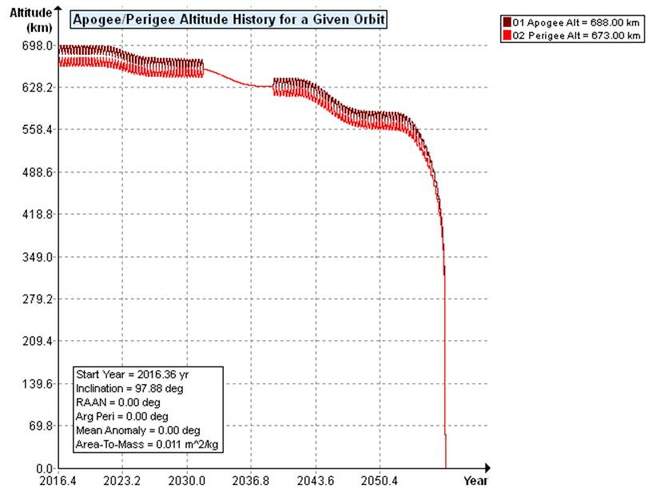

**Figure 2, EO-1 reentry profile and prediction parameters**

1. **EO-1 Flight Operations Team Closeout Activities**

The EO-1 Flight Operations Team (FOT) works on a task on the Ground System and Mission Operations (GSMO) contract. The task monitor will notify the COTR of the intent to reduce the task and provide the expected timeline after HQ approves the decommissioning of EO-1. The EO-1 FOT has been highly optimized over the last 16 years. EO-1 flight operations are fully automated requiring minimal staff. During decommissioning, many manual operations will be performed. To the extent possible, activities necessary to perform the passivation will be pre-loaded as either on-board Real Time Sequences or preset on the ground as command procedures. Since normal operations activities will have been completed by the start of passivation, all attention of the minimal FOT staff will be on executing the passivation activities. It is expected that the existing FOT will be utilized at a normal mission operations level for the entire duration of the passivation. After passivation, the EO-1 FOT will collect all of the final Operations Documentation for the archive and after a two-week waiting period to assure that EO-1 does not “reactivate” itself, the EO-1 FOT will be released.

1. **Ground System Closeout Activities**

Upon notification of the intent to decommission EO-1, the ongoing planned ground system upgrades and IT security patches will be re-evaluated for applicability. Ground system upgrades that will be necessary for the decommissioning activities will be identified and given priority. The team supporting the ground system will primarily stay intact to ensure the viability of all the ground system components during the critical spacecraft decommissioning activities. The ground system configuration will be frozen after 1 September 2016 which any necessary configuration changes will need to be formally approved by the Decommissioning Review team on a waiver basis. During the ground system freeze, system administration and FOT personnel can make updates to the ground system only after approval of each change. Ground system personnel will conduct rehearsals and simulations of passivation activities and support the Decommissioning Review and Disposal Readiness Review. Once the passivation of the spacecraft is verified, the mission-specific components of the ground system can be decommissioned. The data and configurations will be archived before the hardware is wiped and repurposed/excessed. All EO-1 data and documentation will be archived in compliance with the Earth Science Data and Information System Data Preservation Specification including Preflight/Pre-Operations Calibration, Science Data Products, Science Data Product Documentation, Mission Data Calibration, Science Data Product Software, Science Data Product Algorithm Input, Science Data Product Validation and Science Data Software Tools. See Figure 4 for the schedule of activities required for the ground system during and after the decommissioning of the spacecraft.

* 1. **EO-1 Documentation Archive**

Upon verification of spacecraft passivation, the data, documents, and system configurations will be collected and archived, such as:

* Spacecraft Operations Documentation (AETD, Code 580 Spaces, including copies of all operations instructions, special requests, operations logs, handbooks, and specifications)
* Spacecraft Documentation (AETD, Code 580 Spaces, including all subsystem design specifications, Space-to-Ground ICD, and pre-launch reviews)
* Configuration-Managed Documents (AETD, Code 580 Spaces)
* Ground and Flight systems data and software (Flight Project, Code 400 Sharepoint)
* EO-1 Tape Archives (USGS Landsat Archive)
* Spacecraft Housekeeping data (USGS Landsat Archive)

Data archival and length of retention are determined by policies of USGS and AETD. Final documentation will be inventoried, boxed, labeled, and shipped to the National Archives for permanent storage.

* 1. **Facilities/Equipment Disposal**

All EO-1 equipment in the MOC will be wiped and excessed just before FOT personnel are dismissed. Ground system equipment includes:

* All MOC real time servers, flight dynamics, scheduling, front end processer, and level zero processor equipment.
* EO-1 flight software lab equipment
* Spare equipment stored in the Building 14 basement
* The EO-1 library hard copies

EO-1 will return all vacated facilities back to move-in condition.

1. **Budget Analysis**

Decommissioning the EO-1 mission will be supported from the existing FOT, flight dynamics, flight software, and ground system teams. Spacecraft manufacturer and Applied Engineering and Technology Directorate (AETD) subject matter experts will provide support under the budgeted sustaining engineering line item. As the phases of decommissioning progress, minor staffing reductions may be realized in the flight software and manufacturer areas. However, no staffing reductions are expected in the FOT until the passivation has been completed and the equipment has been excessed. The budget for Phase F close-out activities has been removed for this version of the report for posting on the EO-1 website.

**7.0 Conclusions/Summary**

In summary, the complete EO-1 Phase-F process (mission operations and ground systems) will take approximately 10 months that begin and end in FY 2017. Currently the EO-1 mission is healthy and the current projections are for it to operate through the FY2016 with a planned decommissioning phase during FY2017.

**Appendix A**

**Mission Operations Phase - F**

**Charts and Tables**

**Figure 3 EO-1 Passivation Table**

**Figure 4 Ground System Activity Schedule**

|  |  |  |  |
| --- | --- | --- | --- |
| Description | Identification | Prior to Passivation | After Passivation |
| Fluids | Hydrazine Propellant | ~0.3 kg | Nominally Depleted |
|  | (Prior to disposal) |  |
| Pyrotechnic Devices | None | N/A | N/A |
| Electrical Storage | Battery | Fully Operational | Minimum charge rate |
| Electrical Generation | Solar Arrays | Fully Operational | Parked in a neutral position. |
| Experiment Gases | None | N/A | N/A |
| Radioactive Materials | None | N/A | N/A |
| Transmitters | S-Band, X-Band Modulators, | Operational | Powered off |
| X-Band Amplifiers |
| Flight Software | CTC, Relay Switches | Safe State Enabled | Safe State disabled. FDC, RTS, and TSM zeroed out. |
| Pressurant | Nitrogen | >83.66 psi | ~80 psi |
| Mechanical Energy | Three Reaction Wheels | Operational | Spun down, speed set to zero |
|  |  |  |

Figure 3, EO-1 Passivation Configuration

*Jun*

*May*

*Apr*

*Mar*

*Feb*

*Jan*

*Dec*

*2017*

3

Figure 4, Ground System Activity Schedule



*2016*

*2017*

*Sep*

*Oct*

*Nov*

*Dec*

*Jan*

*Feb*

*Mar*

*Apr*

*May*

*Jun*